What you can expect from us:

- We will never just treat short term pain (paracetomol can do that!) We will work to find the true cause and leave you feeling completely confident, going back to the activities that matter most if your life

- Ensure that once the pain has eased, that we safely progress you through the complete treatment plan. It is not unusual to notice a significant reduction in your pain levels quickly but it is important to know there may still be more work to do in your plan to ensure that the problem does not reoccur. Please note it is important if I have advised you not to return to usual activities that you take this advice. I have your best interest at heart, and by working together we can save you time money and effort in the long term and get you back as safely and quickly as possible.

- Complete support throughout the whole process with your movement plan emailed to you the same day of your treatment. If you haven’t received your exercises by the next day, please email me to ensure we have the correct email address

The address for the clinic is Barn Cottage, Newbarn Lane, Seer Green HP9 2QZ. The clinic is located directly opposite Highclere farm.
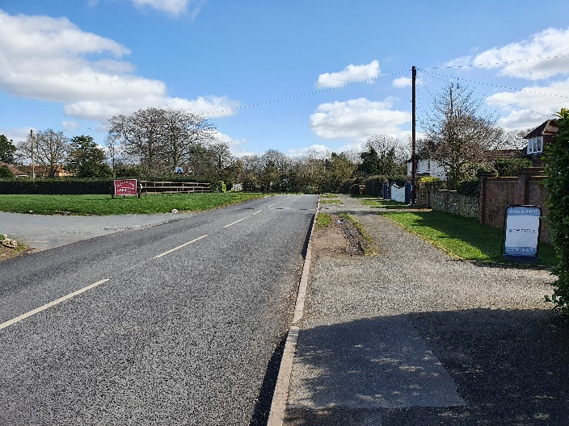
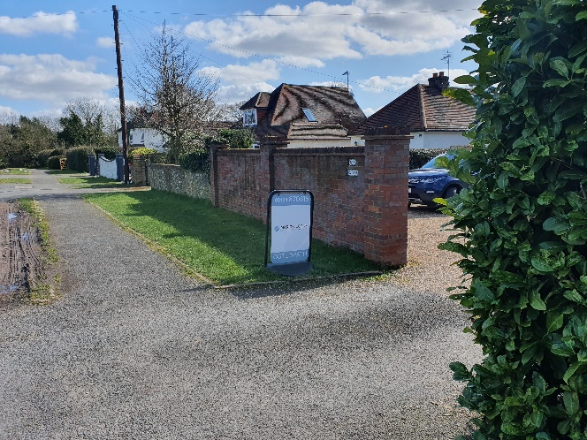

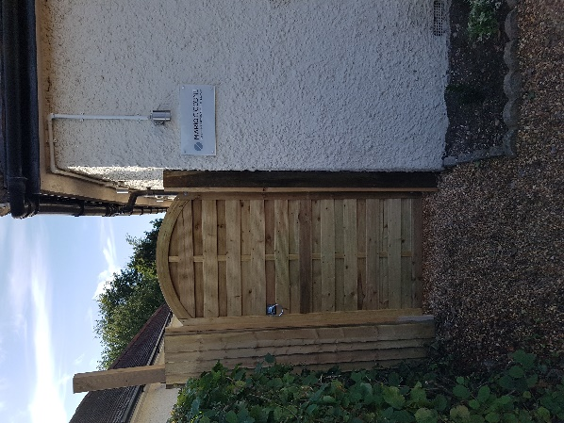
When you arrive at the clinic, please park either on the drive (please do not block in other cars) or on the pavement just outside the house
The clinic is located to the left hand side of the house. Please walk through the gate and follow the path all the way up to the clinic.
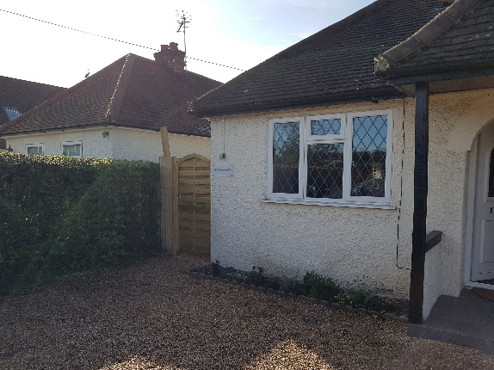

I look forward to working with you and getting you back to living a pain free life!

Best Wishes

Mario Ciccone B. Ost, FAFS

